|  |
| --- |
|  |
| 新概念 3 册 |
| Lesson3 |



**词汇**

1. **archaeologist** archeologist [ɑ:ki'ɒlədʒi]**n. 考古学家**

archaeology / archeology

**“arch(a)” = ancient** 词根：表示古代的

**archaic 古代的**

archaic words 古文字

archaic civilizations 古文明

**“(o)logy” = to study** 词根：去研究

“-ist” 词根：表示 “人”

举例：

**archaeology**

**archaeologist**

**biology biologist**

**geology geologist**

**psychology psychologist**

**physiology physiologist**

**anthropology anthropologist**

1. **prosperous ['prɒspərəs] adj.（经济上）繁荣的**

a prosperous country / businessman

**prosperity adj. 繁荣**

economic prosperity 经济繁荣的

We’ll keep the prosperity and stability of Hong Kong at any cost.

One hundred years later, the Negro lives on a lonely island of poverty in the midst of a vast ocean of material prosperity.

**prosper** vi. 繁荣

A company can’t prosper without investment.

thrive / flourish

A company can’t thrive / flourish without investment.

plants that thrive / flourish in tropical rainforests

a **thriving** / **flourishing** tourist industry

1. **storey** / story ['stɔ:rɪ] **n. 楼层**

storey → storeys

story → stories a two-story house

The house is two stories high.

a multi-story parking lot.

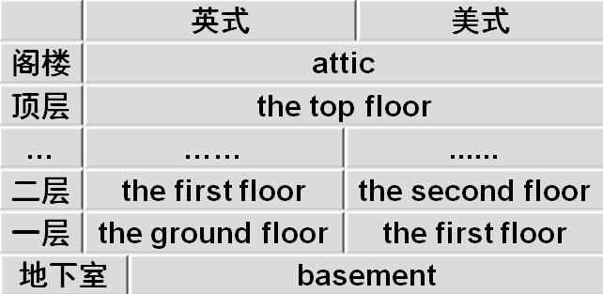**floor 第几层**

1. **sacred** ['seɪkrɪd]**adj. 宗教的；神圣的**

a sacred holiday sacred music

Mecca is a sacred place.

Holy 神圣的

Holy bible 圣经

holy water 圣水

a holy war 圣战

**blessed** 有福的

the Blessed Virgin Mary

It is more blessed to give than to receive.

**divine**

To err is human,to forgive divine.凡人多舛误唯神能见宥 — Alexander Pope

1. **remains** [rɪ'meɪnz] **n. 遗物，遗迹，废墟**

the remains of a meal 剩饭菜

the remains of ancient Rome 遗址

His remains are buried in the churchyard. the rest of sth.

**the remainder of sth**. 其余的，剩余的

the rest of the semester

= the remainder of the semester what is left of sth.

**what is left of sth.**

**=what remains of sth.** 其余的，剩余的

Only two stray dogs benefited from all this confusion, for they greedily devoured what was left of the cake.

It is recounted of Thomas Carlyle that when he heard of the illness of his friend, Henry Taylor, he went off immediately to visit him, carrying with him in his pocket what remained of a bottle of medicine formerly prescribed for an indisposition of Mrs. Carlyle's.

1. **classical** ['klæsikəl] **adj. 古代（希腊和罗马）文化的**

classical studies 古典学

classical music 古典乐

**classic** 经典的

a classic novel 经典小说

加“al”后缀单词含义区别

**electric** 电的 an electric light / razor

**electrical** 跟电相关的 electrical failure 停电

historic 有历史意义的 a historic moment

historical 历史的 historical records 历史纪录

economic 经济的 economic policy 经济政策

economical 节约的 an economical car 节油车

politic 策略的 a politic decision

political 政治的 political asylum

1. **rest** [rest] **v. 倚放，放置**

Her elbows *rested(***vi.***)* on the table.

She rested(**vt.**) her head against a cushion.

**rest on / upon** 基于….基础之上

Columbus’ decision to sail west rests on his belief that the world is round.

**be based / founded on / upon** 基于….基础之上（被动）

**depend on / upon**

**rely on / upon** 基于….基础之上

Don’t always **depend** on others. You should learn to rely on yourself.

While the quality of legal journalism varies greatly, there is an undue **reliance** amongst many journalists on interpretations supplied to them by lawyers.

While comment and reaction from lawyers may enhance stories, it is preferable for journalists to rely on their own notions of significance and make their own judgments.

**课文**

1. Some time ago, an interesting discovery was made by archaeologists on the Aegean island of Kea.

**make a discovery** (of…) 发现

**discover**

make an interesting discovery (of …)

**use**

make **use** of …

make the best **use** of…

He made the best use of his talent. describe

make a vivid description of …

**investigate**

make a thorough **investigation** of …

**summarize**

make a comprehensive **summary** of …

**analyze**

make a detailed analysis of …

Some time ago, *archaeologists made an interesting discovery* on the Aegean island of Kea.对比课文原文重心偏移

A radio message from the mainland had been received by the ship's captain instructing him to give up the search.

“of” 引出地点名称

the city **of** Beijin

the promontory **of** Ayia Irini the tiny village of Perachora

the famous monastery **of** St. Bernard

the novel of Three Kingdoms X 不能引出小说名称

the novel entitled Three Kingdoms 小说

the movie entitled Da Vinci Code 电影

the man named / called Vincen 人

1. An American team explored a temple which stands in an ancient city on the promontory of Ayia Irini.

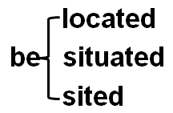an American team of archaeologists

**stand** 矗立在…

Strange forms **stand** in gardens, and outside buildings and shops.

The Monument to the People’s Heroes **stands** in the center of Tian’anmen Square.

**sit** 坐落

The house **sits** on top of a hill overlooking the town.

**lie** 位于（描述大的地点）

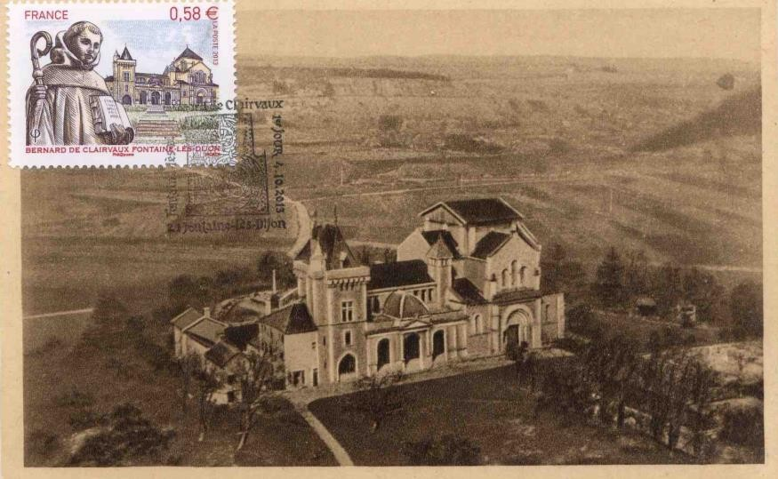The famous monastery of St. Bernard, which was founded in the 11th century, **lies** about a mile away.

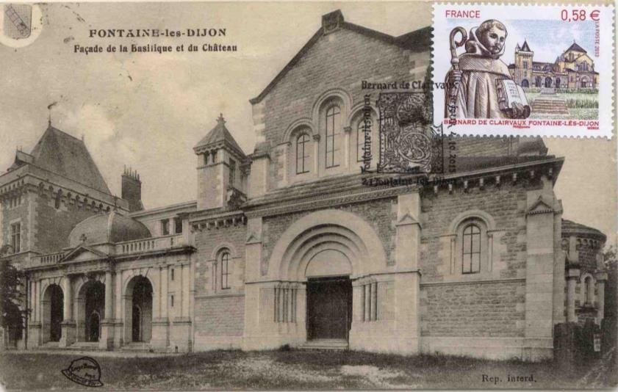

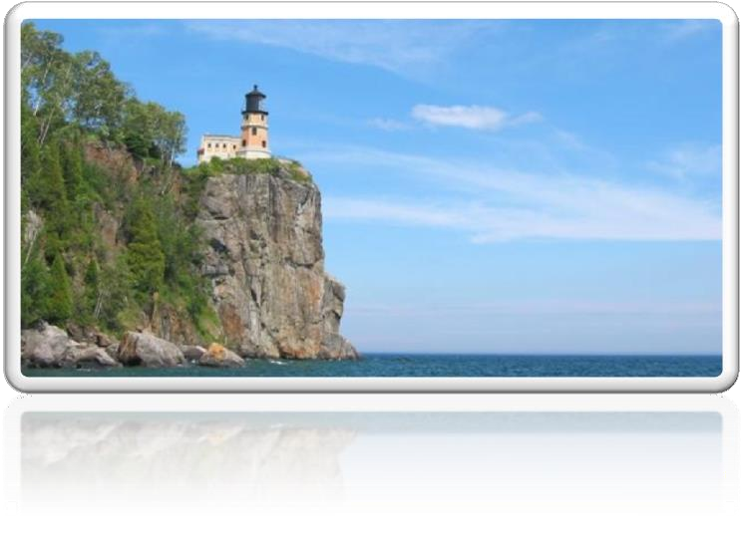promontory (headland) 海岬: a long narrow area of high land that sticks out into the sea.

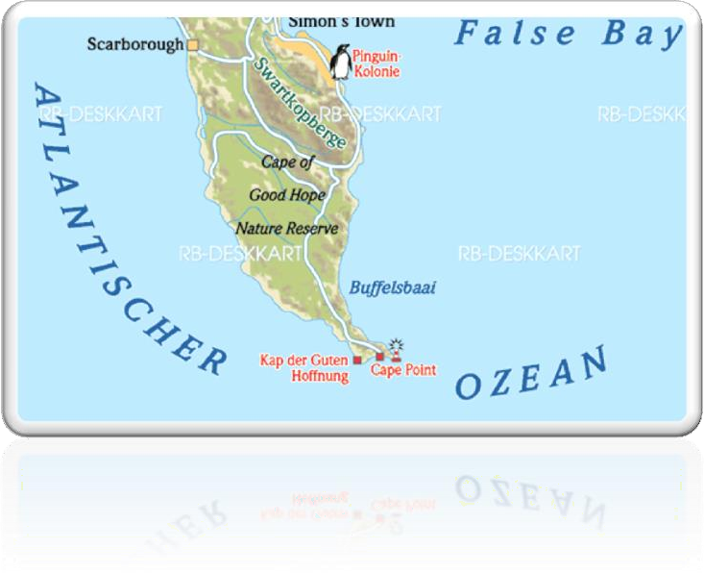cape 海角: a very large piece of land sticking out into the sea

1. The city at one time must have been prosperous, for it enjoyed a high level of civilization.

**at one time = once**

The city at one time must have seen / known prosperity.

**enjoy** 享有

**enjoy** good health

**enjoy** a high standard of living

The garments are magnificent and tasteful and have long **enjoyed** great fame both at home and abroad.

**be blessed with …** 享有

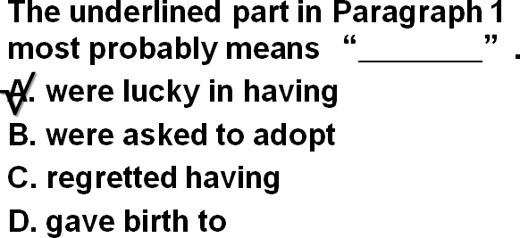They were blessed with two children, a boy and a girl.

**be endowed with …** 天生享有

She **is endowed with** both brains and beauty.

We hold these truths to be self-evident, that all men are created equal, that they **are endowed** by the Creator **with** certain unalienable rights, that among these are life, liberty, and the pursuit of happiness.

― Thomas Jefferson

**boast** 表示“有，拥有”

There is a lot of beautiful scenery in China.

China **boasts** a lot of beautiful scenery.

1. Houses -- often three storeys high -- were built of stone.They had large rooms with beautifully decorated walls.

**with** 此处表示从属关系

a girl **with** blue eyes

a mug **with** a broken handle

**decorate** 装饰，装点

a **vastly** improved method

a much acclaimed novel

1. The city was even equipped with a drainage system, for a great many clay pipes were found beneath the narrow streets.

**equip** 装备

equip A with B

be equipped with …

**equipment** 设备

The classrooms **are equipped with** modern multimedia teaching equipment.

量词

**a great many (of ) …** 可数

**a great number of …** 可数

**a great amount / deal of …** 不可数

a lot of… 可数/不可数

**beneath** / **underneath** （贴着） ➔ on under ➔ over

below ➔ above

1. The temple which the archaeologists explored was used as a place of worship from the fifteenth century B.C. until Roman times.

The temple which the archaeologists explored was used as a place of worship from the fifteenth century B.C. until Roman times.

**be used as …** 被当作…使用

The wooden box **is used as** a seat.

**act / serve / function as …** 当作（必须用主动）

The wooden box acts / serves / functions as a seat.

B.C. (BC): Before Christ 公元前

A.D. (AD): Anno Domini 公元后

**times** 表示“时代，时期”

in modern / recent / ancient / prehistoric times in times of …

in times of …. 在….时代

in times of peace / war

In times of peace, when business was bad, Hawkwood and his men would march into a city-state …

**age** 时代，时期

the Ice Age 冰川时代

the Stone Age 石器时代

the modern age 当代

the computer age 电脑时代

**era / epoch 时代时期**

the steam-engine era / epoch

the end of an era / epoch

His death marked the end of an era.

the beginning of a new era / epoch.

It marked the end of the great tradition of ships with sails and the beginning of **a new era**.

The foundation of the People’s Republic of China marked the beginning of **a new era.**

1. In the most sacred room of the temple, clay fragments of fifteen statues were found. Each of these represented a goddess and had, at one time, been painted.

发音

**t + j = tʃ**

don’**t y**ou

won’**t y**ou

las**t y**ear

nex**t y**ear

si**tu**ation

**represent** 代表

**stand for** 代表

Honey, this gold ring **stands for / represents** my love for you.

**on behalf of ... 代表（介词短语）**

Premier delivered a speech on behalf of the government during the meeting.

Premier delivered a speech representing / standing for the government during the meeting.

1. The body of one statue was found among remains dating from the 15th century B.C.

**date from …** 追述到

**date back to** …追述到

**can be traced back to** …追述到（被动）

造句：丝绸之路 (the Silk Road) 的繁荣可以追溯到遥远的汉朝。

The prosperity of the Silk Road dates from / dates back to / can be traced back to the distant Han Dynasty.

1. Its missing head happened to be among remains of the fifth century B.C.

**happen to do** 碰巧发生

**sth. happen to sb.** 发生

A car accident happened to him.

**it happen that …** 碰巧发生

We **happened to take** the same train.

**It happened that** we took the same train. chance to do

**chanced to do /it chance that …** 碰巧发生

We chanced to take the same train.

**It chanced that** we took the same train.

“碰巧发生”状语：

**by chance**

**by accident**

**accidentally**

We took the same train by chance / by accident / accidentally.

**as it happen** 碰巧发生

As it happened, we took the same train.

**As luck would have it** 碰巧发生(不带感情色彩)

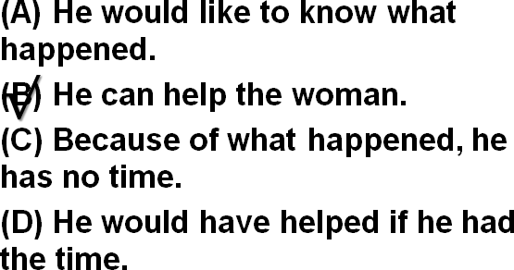

W: I don’t imagine you would have time to help me with this.

M: As it happens, I would.

Q: **What does the man mean?** Answer:

(B) He can help the woman. as luck would have it

**As luck would have it**, we took the same train.

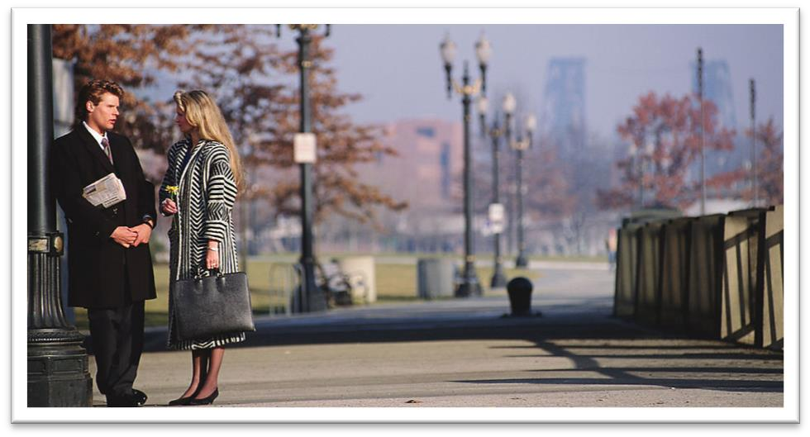W: You do look cold. What happened?

M: I've been standing outside in Arctic temperature for over an hour waiting for a bus.

W: Over an hour, but I thought your apartment was only a ten-minute bus ride to campus.

M: Under normal conditions, but the bus was delayed because of the weather and when I stepped into a drugstore to call home for a ride, the bus went by. **As luck would have it,** there was no one at home, so I had to wait another forty five minutes for the next bus.

W: That's Murphy's law, isn't it. What was it said “If anything can go wrong, it will.” Well, we still get twenty minutes to gather our wits together.

1. This head must have been found in Classical times and carefully preserved.

**preserve** 保护，强调保证质量不下降

preserve one’s eyesight / food

**conserve** 保护，强调保持数量不下降

conserve wildlife / resources

**reserve** 保护，强调保存以备将来使用

Reserve your energy for the climb tomorrow.

All Rights Reserved

I reserve the right to disagree.

reserve a table for 2

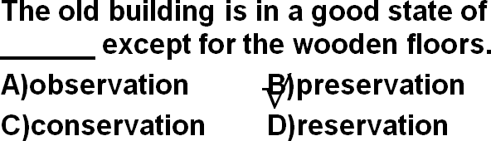

1. It was very old and precious even then.

nerv**ous**

anxi**ous**

1. When the archaeologists reconstructed the fragments, they were amazed to find that the goddess turned out to be a very modern-looking woman.

**动词不定式在句中作状语：目的，原因，结果，条件**

**“使惊讶”**

**amazed**

**surprise**

**astonish**

He was **astonished** at what he found. A man was lying in the box on top of a pile of woolen goods.

**amaze** 强调迷惑不解的惊讶

**astound** 强调把某人惊呆了

The police were astounded when Mrs. Ramsay told them what she had done.

**对单词的精准理解，有助于加深对文章的印象和理解作者表达的精确含义。**

**turn out to be** 原来是这样的，强调出乎意料

prove (to be)

Eric’s girlfriend **turned out to be** his half-sister.

**modern-looking** 复合形容词代替定语从句

an **interesting-looking** carved dagger

**hard-working**

**easy-going**

1. She stood three feet high and her hands rested on her hips.

**stand** 在这是系动词，表示“有多高”，后面有数量词作表语

The tower **stands** 15 meters (high).

**weigh** 系动词，表“有多重”

The boy weighs 50 kilos.

**measure** 系动词，表“有多长/宽/高/深

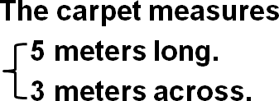

**rest on** 托着

Her hands **rested on** her hips.

Her face **rested on** her hands.

1. She was wearing a full-length skirt which swept the ground.
2. Despite her great age, she was very graceful indeed, but, so far, the archaeologists have been unable to discover her identity.

“尽管”，引导让步的介词

**despite**

**in spite of**

**notwithstanding**

“尽管”，连词

**though**

**although**

**even though**

**while**

介词改成连词

**in spite of the fact that …**

**despite the fact that …**

**Despite the fact that** the bottle is tinted a delicate shade of green, an observant visitor would soon notice that it is filled with what looks like a thick, grayish substance.

**如何写出引人入胜的叙事类文章？**

制造悬念(有趣发现)→层层深入,迫近主题(古城→庙宇→殿堂→神像)→揭示谜底,故事高潮

(身首异处,摩登女郎)→尾声,意犹未尽(身份未知)